
NUR SABIQAH ADANI AHMAD FAIQUE
I/C Number | : 960609-03-5552 |   Lot 1905, Lorong Jaya, Kampung Tanjung Mas, 15400, Kb Kelantan | 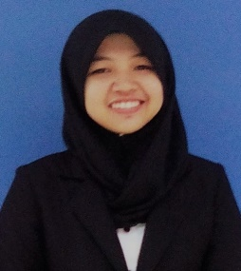
Age | : 23
Marital Status | : Single |   schabby.96@gmail.com
Health | : Excellent
Availability | : Sept 2018 |   +601125406726

SUMMARY
A business management majoring in investment analysis. Currently having a semester break in doing my degree and looking for a permanent job that suits my major. Potentially capable of handling various tasks, embracing new challenges and adapting to new environment. Willing to contribute my skills especially in technical and industrial skills to the company. Also hoping in gaining experiences which enable me to grow professionally while meeting the company’s goal.

ACADEMIC QUALIFICATIONS |  |  | PERSONAL SKILLS
2019-2020 | MARA University of Technology(UiTM), Dungun, Terengganu  Bachelor in in International Business (not yet graduated) |  | Attribute | Determined, Hardworking, Teamwork, Honest
2015-2018 | MARA University of Technology (UiTM), Dungun, Terengganu  Diploma in Investment Analysis CGPA 2.70 |  | Languages | Malay
 |  |  |  | English
 |  |  |  | Arabic
2009-2013 | SMU (A) Maahad Pengajian Islam, KB, Kelantan  Malaysian Certificate of Eduation (SPM)  4A, 3B, 2C |  | Software | Microsoft (Word, Excel, Powerpoint)  Powtoon, Canva

WORKING EXPERIENCE
2015 (for 3months while waiting for SPM’s result)  2016 (for a month during semester break)  2018-2019 | Part time waitress at Shikin Nasi Ayam (be a waitress which is taking an order and delivered to the customer)  Part time sales promoter at Hawany Hijab (promote the scarves to the customer)  Marketing manager at Ever Last.co
REFERENCES
Lecturer Lecturer
A’tiqah Rashidah Abu Samah Roseziahazni Abdul Ghani
Lecturer/UiTM Dungun, Terengganu Lecturer/UiTM Dungun, Terengganu
atiqahr@gmail.com (012-4298414) roszi@gmail.com (016-941002)

